Customer Sync Pipeline
Code:
import os
import logging
from datetime import datetime, timedelta

import pandas as pd

# from airflow.decorators import dag
from airflow import DAG
from airflow.operators.python import PythonOperator, BranchPythonOperator
from airflow.providers.snowflake.hooks.snowflake import SnowflakeHook
from airflow.exceptions import AirflowException

logger = logging.getLogger(__name__)

def alert_on_failure(context):
ti = context["task_instance"]
dag_id = ti.dag_id
task_id = ti.task_id
print(f"ALERT: Task {task_id} in DAG {dag_id} has failed. Check the logs.")

def validate_file():

try:

file_path = "data/customers_data.csv"

if not os.path.exists(file_path):
raise AirflowException(
"customers_data.csv not found"
)

logger.info(
"CSV file found — proceeding with load."
)

return file_path

except AirflowException:
raise

except Exception as e:
logger.error(f"Error in validate_file: {str(e)}")
raise AirflowException(f"validate_file failed: {str(e)}")

def create_and_load():

try:

hook = SnowflakeHook(
snowflake_conn_id='snowflake_default'
)

# Create table
create_table_sql = """
CREATE TABLE IF NOT EXISTS RAW_CUSTOMERS (
customer_id INT,
name VARCHAR,
email VARCHAR,
city VARCHAR,
signup_date DATE,
plan VARCHAR,
loaded_at TIMESTAMP
);
"""

hook.run(create_table_sql)

logger.info("RAW_CUSTOMERS table ready.")

# Idempotency delete
hook.run("""
DELETE FROM RAW_CUSTOMERS
WHERE loaded_at::DATE = CURRENT_DATE();
""")

logger.info("Cleared today's existing RAW_CUSTOMERS rows.")

# Read CSV and insert rows
# Read CSV and insert rows
file_path = "data/customers_data.csv"
df = pd.read_csv(file_path)

values_list = []

for _, row in df.iterrows():

name = str(row['name']).replace("'", "''")
email = str(row['email']).replace("'", "''")
city = str(row['city']).replace("'", "''")
plan = str(row['plan']).replace("'", "''")

values_list.append(f"""
(
{row['customer_id']},
'{name}',
'{email}',
'{city}',
'{row['signup_date']}',
'{plan}',
CURRENT_TIMESTAMP()
)
""")

# Insert in batches of 100
batch_size = 100

for i in range(0, len(values_list), batch_size):

batch = values_list[i: i + batch_size]

insert_sql = f"""
INSERT INTO RAW_CUSTOMERS (
customer_id,
name,
email,
city,
signup_date,
plan,
loaded_at
)
VALUES {', '.join(batch)};
"""

hook.run(insert_sql)

logger.info(
f"Inserted batch {i // batch_size + 1} "
f"({len(batch)} rows)."
)

logger.info(f"Loaded {len(df)} rows into RAW_CUSTOMERS.")

except AirflowException:
raise

except Exception as e:
logger.error(f"Error in create_and_load: {str(e)}")
raise AirflowException(f"create_and_load failed: {str(e)}")

def enrich_customers():

try:

hook = SnowflakeHook(
snowflake_conn_id='snowflake_default'
)

# Create enriched table
create_enriched_sql = """
CREATE TABLE IF NOT EXISTS ENRICHED_CUSTOMERS (
customer_id INT,
name VARCHAR,
email VARCHAR,
city VARCHAR,
signup_date DATE,
plan VARCHAR,
customer_tier VARCHAR,
days_since_signup INT,
loaded_at TIMESTAMP
);
"""

hook.run(create_enriched_sql)

logger.info("ENRICHED_CUSTOMERS table ready.")

# Idempotency delete
hook.run("""
DELETE FROM ENRICHED_CUSTOMERS
WHERE loaded_at::DATE = CURRENT_DATE();
""")

logger.info("Cleared today's existing ENRICHED_CUSTOMERS rows.")

# Insert enriched data
insert_enriched_sql = """
INSERT INTO ENRICHED_CUSTOMERS (
customer_id,
name,
email,
city,
signup_date,
plan,
customer_tier,
days_since_signup,
loaded_at
)
SELECT
customer_id,
name,
email,
city,
signup_date,
plan,
CASE WHEN plan = 'premium' THEN 'Premium Tier' ELSE 'Basic Tier' END,
DATEDIFF('day', signup_date, CURRENT_DATE()),
CURRENT_TIMESTAMP()
FROM RAW_CUSTOMERS
WHERE loaded_at::DATE = CURRENT_DATE();
"""

hook.run(insert_enriched_sql)

# Log enriched row count
count = hook.get_first("""
SELECT COUNT(*)
FROM ENRICHED_CUSTOMERS
WHERE loaded_at::DATE = CURRENT_DATE();
""")[0]

logger.info(f"{count} enriched rows created in ENRICHED_CUSTOMERS.")

except AirflowException:
raise

except Exception as e:
logger.error(f"Error in enrich_customers: {str(e)}")
raise AirflowException(f"enrich_customers failed: {str(e)}")

def quality_check():

try:

hook = SnowflakeHook(
snowflake_conn_id='snowflake_default'
)

# Check 1 — NULL check
null_count = hook.get_first("""
SELECT COUNT(*)
FROM ENRICHED_CUSTOMERS
WHERE (name IS NULL OR email IS NULL)
AND loaded_at::DATE = CURRENT_DATE();
""")[0]

logger.info(f"NULL check result: {null_count} rows with nulls.")

# Check 2 — Duplicate check
duplicate_count = hook.get_first("""
SELECT COUNT(*) - COUNT(DISTINCT customer_id)
FROM ENRICHED_CUSTOMERS
WHERE loaded_at::DATE = CURRENT_DATE();
""")[0]

logger.info(f"Duplicate check result: {duplicate_count} duplicate customer_ids.")

if null_count == 0 and duplicate_count == 0:
logger.info("Both checks passed — routing to all_clear.")
return "all_clear"
else:
logger.warning("One or more checks failed — routing to data_warning.")
return "data_warning"

except AirflowException:
raise

except Exception as e:
logger.error(f"Error in quality_check: {str(e)}")
raise AirflowException(f"quality_check failed: {str(e)}")

def all_clear():

try:

hook = SnowflakeHook(
snowflake_conn_id='snowflake_default'
)

logger.info(
"Quality checks passed — customer data is clean."
)

count = hook.get_first("""
SELECT COUNT(*)
FROM ENRICHED_CUSTOMERS
WHERE loaded_at::DATE = CURRENT_DATE();
""")[0]

logger.info(f"Total enriched rows for today: {count}")

except AirflowException:
raise

except Exception as e:
logger.error(f"Error in all_clear: {str(e)}")
raise AirflowException(f"all_clear failed: {str(e)}")

def data_warning():

try:

hook = SnowflakeHook(
snowflake_conn_id='snowflake_default'
)

null_count = hook.get_first("""
SELECT COUNT(*)
FROM ENRICHED_CUSTOMERS
WHERE (name IS NULL OR email IS NULL)
AND loaded_at::DATE = CURRENT_DATE();
""")[0]

duplicate_count = hook.get_first("""
SELECT COUNT(*) - COUNT(DISTINCT customer_id)
FROM ENRICHED_CUSTOMERS
WHERE loaded_at::DATE = CURRENT_DATE();
""")[0]

logger.warning(
"WARNING: Data quality issues detected in customer load."
)

if null_count > 0:
logger.warning(f"NULL check FAILED — {null_count} rows with null name or email.")

if duplicate_count > 0:
logger.warning(f"Duplicate check FAILED — {duplicate_count} duplicate customer_ids.")

except AirflowException:
raise

except Exception as e:
logger.error(f"Error in data_warning: {str(e)}")
raise AirflowException(f"data_warning failed: {str(e)}")

def final_summary():

try:

hook = SnowflakeHook(
snowflake_conn_id='snowflake_default'
)

summary = hook.get_records("""
SELECT
COUNT(*) AS total_customers,
SUM(CASE WHEN customer_tier = 'Premium Tier' THEN 1 ELSE 0 END) AS premium_count,
SUM(CASE WHEN customer_tier = 'Basic Tier' THEN 1 ELSE 0 END) AS basic_count,
ROUND(AVG(days_since_signup), 1) AS avg_days_since_signup,
MODE(city) AS top_city
FROM ENRICHED_CUSTOMERS
WHERE loaded_at::DATE = CURRENT_DATE();
""")

row = summary[0]

logger.info(f"Total Customers: {row[0]}")
logger.info(f"Premium Tier: {row[1]}")
logger.info(f"Basic Tier: {row[2]}")
logger.info(f"Average Days Since Signup: {row[3]}")
logger.info(f"City with Most Customers: {row[4]}")

except AirflowException:
raise

except Exception as e:
logger.error(f"Error in final_summary: {str(e)}")
raise AirflowException(f"final_summary failed: {str(e)}")
default_args = {
'owner': 'airflow',
'retries': 1,
'retry_delay': timedelta(minutes=5),
'on_failure_callback': alert_on_failure
}

with DAG(
dag_id='customer_sync',
schedule='@daily',
start_date=datetime(2023, 1, 1),
catchup=False,
default_args=default_args,
on_failure_callback=alert_on_failure
) as dag:

validate_file_task = PythonOperator(
task_id='validate_file',
python_callable=validate_file
)

create_and_load_task = PythonOperator(
task_id='create_and_load',
python_callable=create_and_load
)

enrich_customers_task = PythonOperator(
task_id='enrich_customers',
python_callable=enrich_customers
)

quality_check_task = BranchPythonOperator(
task_id='quality_check',
python_callable=quality_check
)

all_clear_task = PythonOperator(
task_id='all_clear',
python_callable=all_clear
)

data_warning_task = PythonOperator(
task_id='data_warning',
python_callable=data_warning
)

final_summary_task = PythonOperator(
task_id='final_summary',
python_callable=final_summary,
trigger_rule='none_failed_min_one_success'
)

validate_file_task >> create_and_load_task >> enrich_customers_task >> quality_check_task
quality_check_task >> [all_clear_task, data_warning_task] >> final_summary_task

- Graph View — Run A: all_clear GREEN, data_warning pink (skipped), final_summary GREEN
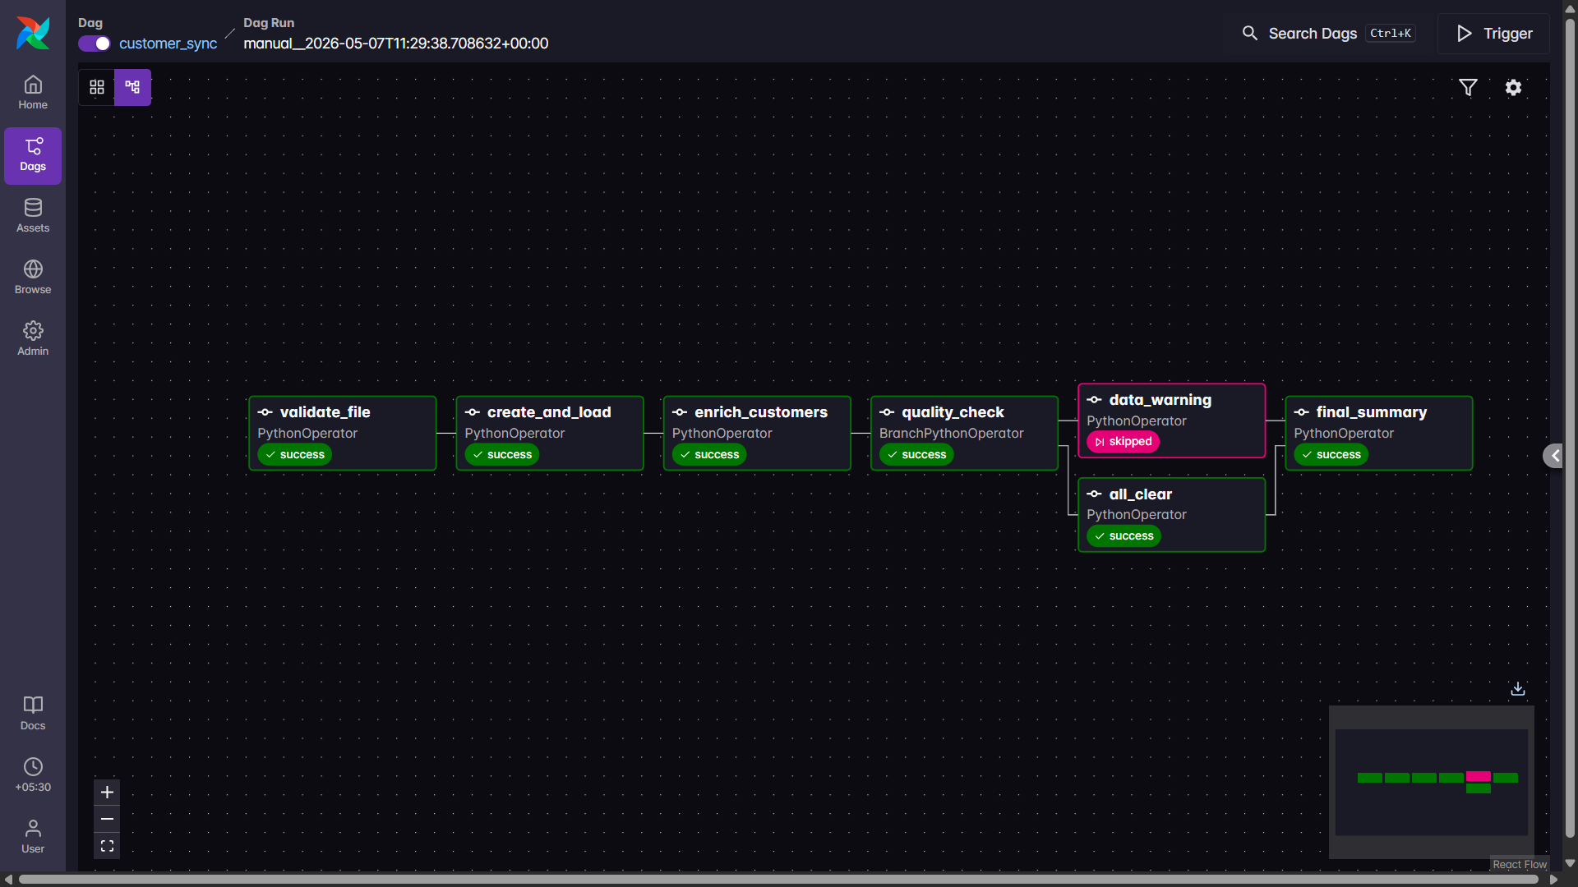
- Graph View — Run B (add a bad row to trigger warning): data_warning GREEN, all_clear pink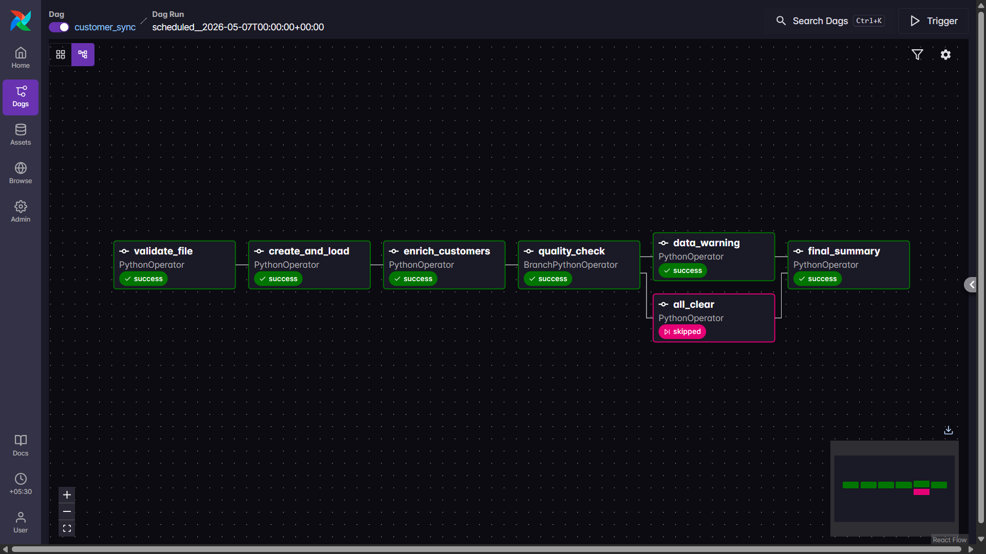
- Snowflake Worksheet — SELECT * FROM ENRICHED_CUSTOMERS showing customer_tier and
days_since_signup
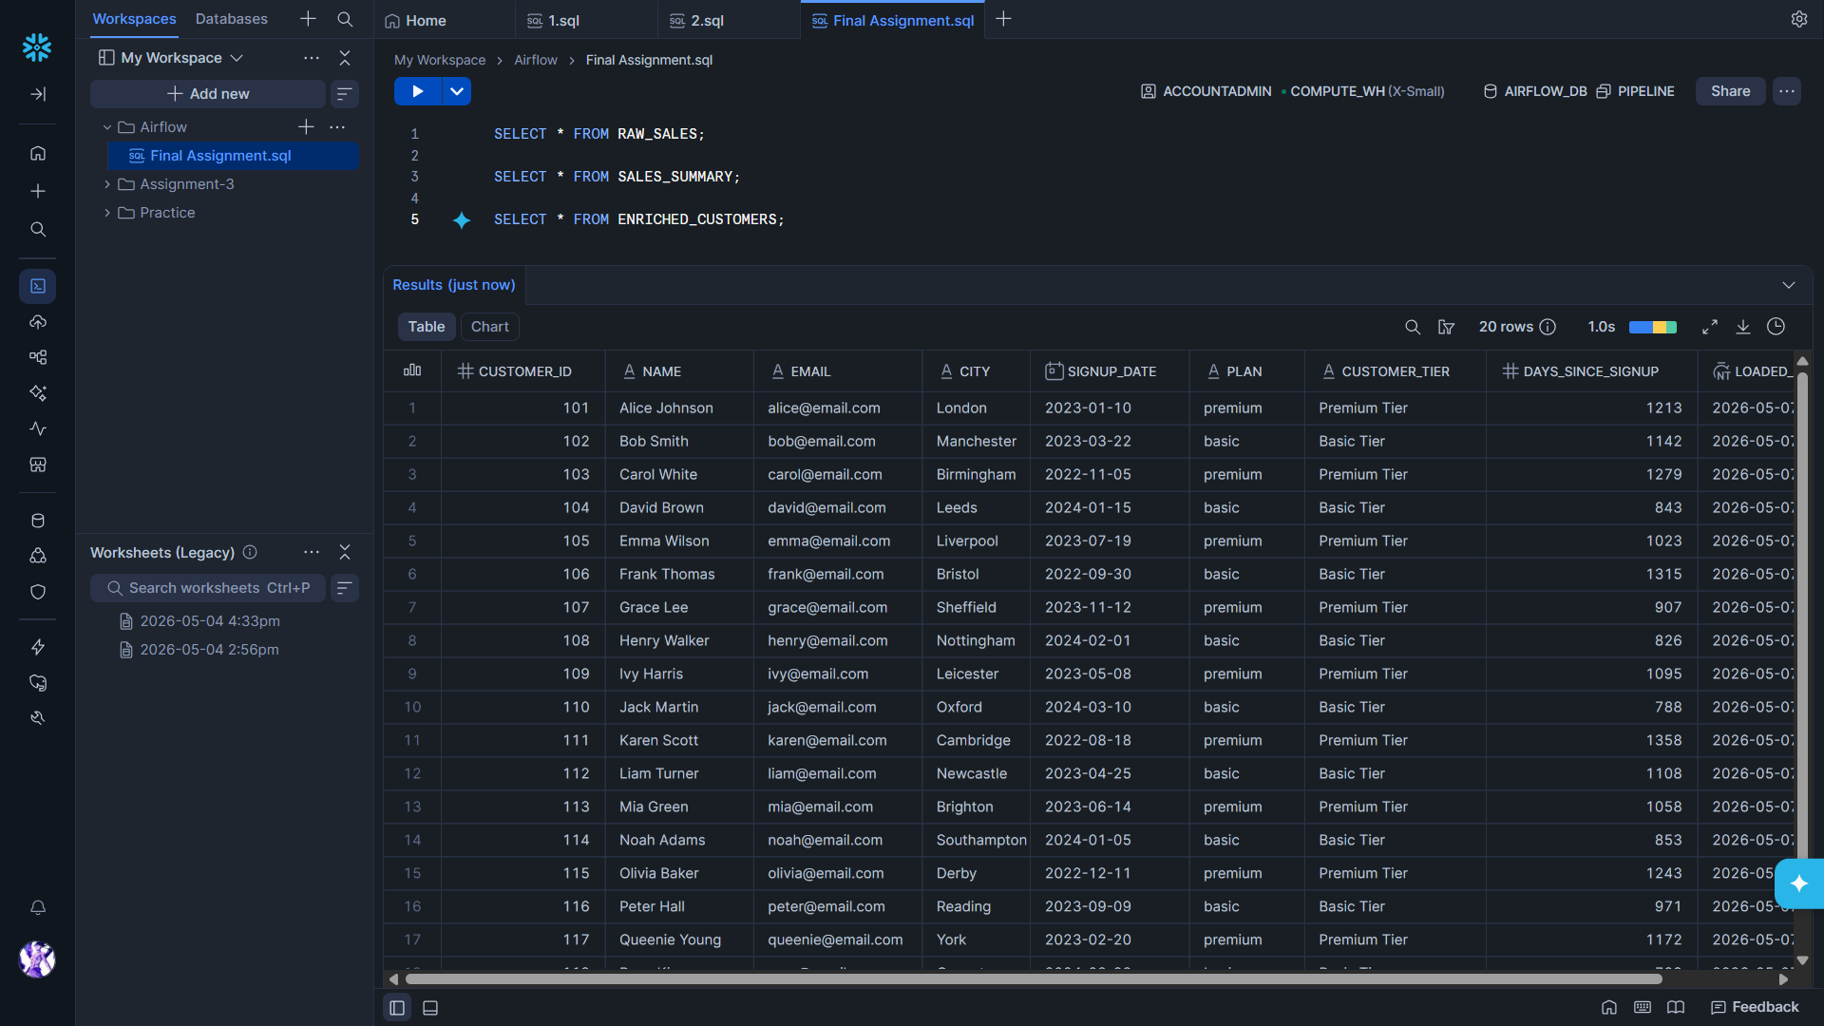

- Task Log of quality_check — both check values logged before the branch decision
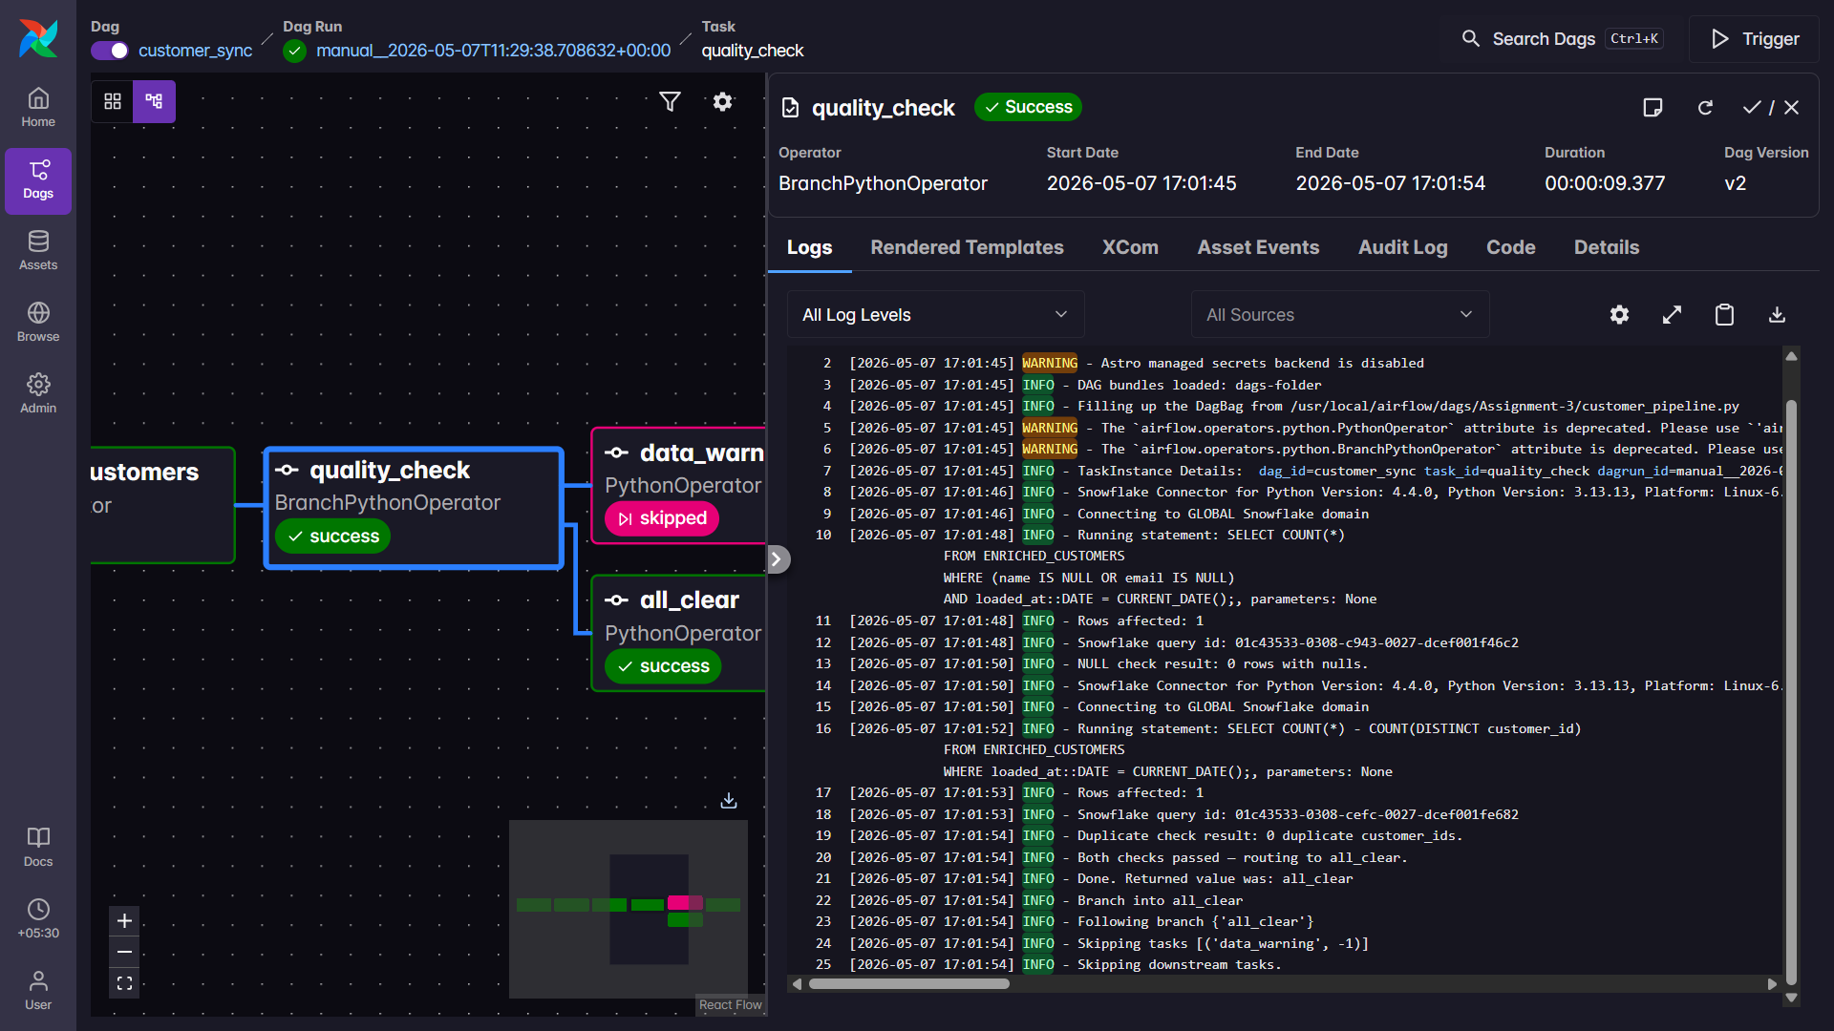
- Task Log of final_summary — tier breakdown report with averages
